ENHANCING IN LEARNING MANAGEMENT SYSTEM USING MACHINE LEARNING

Dr. B.JAISON*, Pavan Kumar.PC** , S.Siranjeevi** , R.Vijay**

*Assistant Professor, **UG Students

Department of Computer Science And Engineering,

RMK Engineering College

[Bjn.cse@rmkec.ac.in](mailto:Bjn.cse@rmkec.ac.in), [Pavale17416.cs@rmkec.ac.in](mailto:Pavale17416.cs@rmkec.ac.in) ,

[Sirale17413.cs@rmkec.ac.in](mailto:Sirale17413.cs@rmkec.ac.in) , [Vijale17417.cs@rmkec.ac.in](mailto:Vijale17417.cs@rmkec.ac.in)

**ABSTRACT:**

Learning management system (LMS ) make sure students to choose from a wide variety of course at their convenience. But it is practiced common for all the students, so there's a need to customize platform according to their learning ability and need. This customization is done by analyzing their user behavior and academic data performance in the learning environment. Teaching techniques are customized based on user abilities. We collect data after each session, using Machine Learning we are analysing and categorising students based on their ability to provide personalized learning content the purpose of this study is to understand how student behave in the online learning environment and predict students grades, researches grades, researchers are interested in understanding if there is any association between students’ interactivities and their final grades.This is use to analyses how the behaviour patterns in the interaction of each particular student with the contents and services in a learning management system (LMS) can be used to predict student motivation and if this student motivation can be used to predict the successful completion of an e-learning course. (LMS) lack automated intelligent components that analyse data and classify learners in terms of their respective characteristics have used machine learning methods such as k-nearest neighbour (KNN). Machine learning concepts were identified from the log records. The dataset was split into

training and testing set. A model using K-NN algorithm designed and implemented This e-learning scenario offers a particularly valuable opportunity to achieve the goal of analysing motivational factors in e-learning courses

**KEYWORDS**

learning style, learning management system, learner modelling, learner behaviour, machine learning, k-nearest neighbour

**1. INTRODUCTION:**

E-learning in the past several years, education data analysis has become a promising research field where the learning can be quantified to improve the educational effectiveness. More and more cadres’ E-learning platform is also working, the Chongqing E-learning Academy for Leadership is one of them, and which requires the student must take part in learning an do obtain a certain credit and the learning situation will be assessed by government departments. When students log in the E-learning platform, the learning data are saved in the database. A Learning Management System, which was developed to furnish online education, stores each record of the user interaction in the system as log entries [1]. These log records makes a massive data storage, which contain all the information about the user interactions with the system The data mainly includes the basic information (such as name, id, gender etc.) and the study records (such as the completion situation of the course, login times, learning times etc.), which hid the cadres’ learning behavior. How to use the data and find the learning behavior has become very crucial. during the last years, the enormous development in the field of learning behaviour analysis has been made with big data technology. There are many research achievements about online learning behaviour analysis, most of them discuss the model of online learning behaviour its becomes increasingly popular due to its flexibility compared to offline learning fixed mode. Flexibility means that learners can choose to conduct learning activities in e-learning. However, flexibility also brings a challenge which is how to arrange appropriate learning activities for learners to improve their learning experience. To formulate appropriate policies for learners, e-learning platform managers need to understand the factors that influence learners' academic performance It has been reported that individuals have different learning preferences and cognitive behaviour regarding leaning materials they use. Learning style is defined as the most preferred mode of instruction or study. Some examples of learning style theories include Felder Silver Model Myers Briggs Type indicator, Kolb learning model and VARK learning styles. The problem with LMS is lack of features that automatically analyse records of students’ access to generate knowledge on individual behaviour such as learning styles and cognitive traits but instead treat learners equally. Instructors have previously administered manual instruments such as Index of Learning Style (ILS) questionnaire and psychometric tests like operation task span to gather information on learning styles and cognitive traits respectively.

**2. PROBLEM FORMULATION:**

**2.1. SYSTEM MODEL:**

**2.1.1. EXISTING SYSTEM:**

In previous learning management system, we take final result as the primary evaluating factor to evaluate a student. The point we miss is that not all students learn in same way or in same method which makes the system ineffective Every student or user who uses e-learning platform should get personalized learning material or content in order to bring the best out of him/her. investigate the relationship between students characteristic and online behavior .Learning Management Systems (LMSs) follow static course flows which is not personalized for each and every user. It is unfair to evaluate the students’ performance only by final score but not with their behavior and activities throughout the course. So, learning contents (materials) should be provided in such a way that a student enjoys the most to get the best of him/her out. This study conducted experiments on student population which is the most representative in e-learning. Firstly, the original data set is pre-processed. secondly, different classification methods are applied to the data sets to produce

student models; and finally, Introduced the evaluation method and evaluation metrics used to evaluate the experimental model.the dynamic behaviour of students from learning behaviour factors and credit and assessment factors and correlation of elective course. In our analysis results, we can find some learning rules. These results can guide us to improve the E-learning platform and improve the learning efficiency.

**2.1.2. DISADVANTAGES OF EXISTING SYSTEM:**

It fails to know the mental ability of the student. Contents are static and common to all students throughout the course. Hence, helpless to know the result in the end. Only suits for quiz related online competition. Lack of personalization. Its not give accurate results based on student behavior and interests. security issues arise when there is no proper authentication and authorization mechanisms

**3. THE PROPOSED SCHEMES:**

**3.1. PROPOSED SYSTEM**

Since different student/user needs different kind of contents to learn comfortably and efficiently, it is mandatory to provide such learning materials/contents that matches their interests. In the proposed system, student behaviors and activities are monitored and collected and learning material/contents are given according to their interests. This will enhance the learning process through interactive content by better teaching techniques. In this approach, the system ensures every student/user learns all the contents given in the course without fail. It’s used to k nearest neighbour algorithm to categorized the data sets in students logs and behaviour result and personalizes data using machine learning.

**3.1.1. ADVANTAGES**

Data are well categorized Understanding the student’s motivational state psychology towards e-learning system. Gives the best way to understand the Correlation between students. Identifying students learning style categories. Finding the usefulness of learning activities provided by the course. Behavior can be predicated for student mentality teaching method can be applied in learning management system

**4.SYSTEM ARCHITECTURE:**

Student enter in this LMS to login id and password and enter into the teaching content like videos and document materials and then questions can given to the students analyze the person interested attend test if students was

struggled in test tutorial can be used to make the use of successfully attend the test. than results and student activities can be collected this data can categorized using machine learning in k nearest neighbor algorithm finally learning content store data for future evaluation.

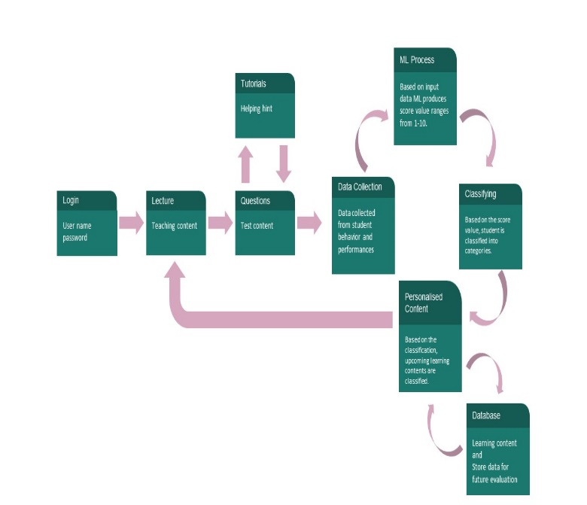

**4.1 MODULE DESCRIPTION:**

* Teaching module
* Data & machine learning module

**4.2 TEACHING MODULE:**

Teaching contents and Learning Activity contents comes under this module. User Inputs and Behavior data are collected. Student/user gets assist with learning content based on his/her ability. User have learning activities can be done by this module. user have user id password to access this module is given to learning material Videos, documents for purpose of studying clearly user attend the test through the study activities.

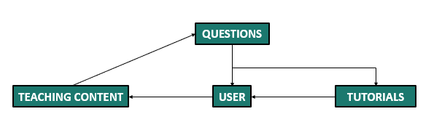

**4.3 DATA AND MACHINE LEARNING MODULE:**

Data collected from Teaching module is mapped with Felder Silverman Method (FSM). Mapped data then processed using K-Nearest Neighbor Machine Learning algorithm. Depending on the score value ML provided and learning contents/material are provided. Felder Silverman Learning Style Model (FSLSM). This theory classifies a leaner as active or reflective, sensing or intuitive, visual or verbal, sequential or global. The study assumes there exists a relationship between the learning traits and online browsing behaviour. The study analysed access records of e-books hosted in LMS, analysed and classified students by mapping to the dimensions proposed in the theory.

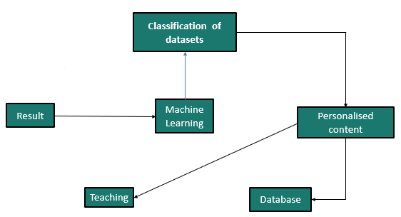

**5. TECHNIQUES AND ALGORITHMS:**

Student behaviors are monitored using event handlers and logged with help of Log4j framework. At the end of every section, accumulated logged data and performance data are formed as datasets to be processed by Machine Learning System. Before Machine Learning process, datasets are mapped to the learning styles of Felder Silverman method (FSM). Mapped Datasets are processed using K-Nearest Neighbors Machine Learning Algorithm, and as output, a score value is obtained. Score value ranges from 1-10. Based on the score value, students’ state in current chapter will be identified. And learning material (or content) for next chapter is personalized using that state. Step 1-5 are repeated till the end of the course.

**6. CONCLUSION**

This paper has demonstrated how a machine learning approach can be used to predict LS based on a learning theory. It is feasible on larger scale to predict learning styles from corpus of historical data to enable instructors provide personalized learning and education. The prototype plugin can be integrated with existing learning management system platform to automatically present learning materials matching individual behavior. This is done by continuously analyzing system access records to classify leaners and match contents to learning styles. The model evaluation progress is giving promising results. This is work on progress and it is envisaged that the model will generate more accurate results after proper training and validation. Additional tests are being carried out to improve the performance of the model

**7.REFERENCE**

[1] Qianguo Chen Learning Behaviour Analysis and Prediction Based on E-Learning Platform Data year: 2017

[2] Pedro J. Muñoz-Merino, and Carlos Delgado Kloos Student Behavior and Interaction Patterns with an LMS as Motivation Predictors in E-Learning Settings Year: 2013

[3] Ai-lun wu, Shun-jyh wu and Shu-ling lin Grey relational analysis of students’behavior in lms Year: 2016

[4] Junjie Hou, Yiping Wen Prediction of learner’s academic performance using factorization machine and decision tree

Year: 2019

[5] Ratnapala I P, Ragel R G, Deegalla S. Students behavioural analysis in an online learning environment using data mining[C] International Conference on Information and Automation for Sustainability. IEEE, 2014.J.

[6] T. Thiele, A. Singleton, D. Pope and D. Stanistreet, "Predicting students' academic performance based on school and sociodemographic characteristics," Studies in Higher Education, vol. 41, no. 8, pp. 1-23, 2016, doi: 10.1080/03075079.2014.974528.

[7] Y. Kuo, J. Chen, Y.Jeng, and Y. Huang, "Real-time learning behaviour mining for e-learning," The 2005 IEEE/WIC/ACM

International Conference on Web Intelligence, 2005, pp. 653-656, doi:10.1109/WI.2005.125.

[8] S. Honey church, A. Bozkurt, L. Singh, and A. Kouropoulos, “Learners on the Periphery: Larker’s as Invisible Learners,” *Eur. J. Open*, vol. 20, no. 1, pp. 191–1027, 2017.

[9] D. Kolb, A., *experimental Learning: Experience as the Source of Learning and dw*, 2nd ed. Pearson Education, 2015.

[10] D. W. Huang, H. Diefes-Dux, P. K. Imbrie, B. Daku, and J. G. Kallimani, “Learning motivation evaluation for a computer-based instructional

tutorial using ARCS model of motivational design,” in *Proc. IEEE FIE Conf.*, Savannah, GA, 2004, pp.